This is the book I referred to in the video.

I highly recommend reading [the book](https://www.amazon.com/Effective-Data-Storytelling-Narrative-Visuals/dp/1119615712) and following Brent Dykes on [LinkedIn](https://www.linkedin.com/posts/brentdykes_data-datastorytelling-analytics-activity-6878759325993635840-XaFj). Brent's work is amazing.

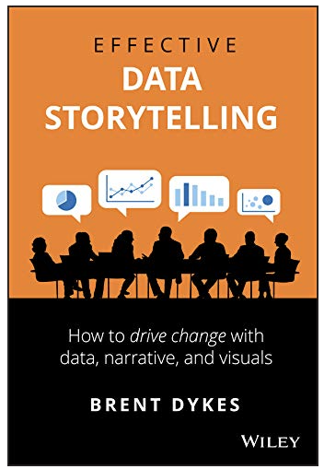  
﻿﻿

**I also spoke with Brent on the** [**MindSpeaking podcast:**](https://www.mindspeaking.com/post/data-storytelling-when-and-how-to-communicate-your-data-in-stories)

 Apple:<https://apple.co/3asxLbD>

 Spotify:<https://spoti.fi/3ItZapZ>

️ YouTube (with timestamps):<https://youtu.be/VWD3VFJ9TvI>

﻿﻿